BMS INSTITUTE OF TECHNOLOGY & MANAGEMENT

Yelahanka, Bengaluru – 560 064



Department of Computer Science and Engineering

Synopsis for the Project work

“Pressure Ulcer Prediction and Prevention”

Submitted By:

1. A Nitya Dyuthi 1BY18CS001

2. Khuswinder Singh 1BY18CS074

3. Likith S 1BY18CS081

4. Prakhyat 1BY18CS108

Under the Guidance of

Mrs. Durga Bhavani A

2021-2022

**BMS INSTITUTE OF TECHNOLOGY & MANAGEMENT**

Avalahalli, Yelahanka, Bengaluru-560064

**Department of Computer Science and Engineering**



**Project Synopsis (18CSP77)**

**Academic Year 2021-22**

| **Batch No:**  **15** | | **Guide Name:**  **Mrs. Durga Bhavani A** | | **Submission Date:**  **09-11-2021** |
| --- | --- | --- | --- | --- |
| **Project Title**    **Pressure Ulcer Prediction and Prevention** | | | | |
| **Sl No** | **USN** | | **Name** | |
| **1** | **1BY18CS001** | | **A Nitya Dyuthi** | |
| **2** | **1BY18CS074** | | **Khuswinder Singh** | |
| **3** | **1BY18CS081** | | **Likith S** | |
| **4** | **1BY18CS108** | | **Prakhyat** | |
| **Project Execution Place** | | | **In-house** | |
| **Project Category** | | | **Research and Societal** | |

**Abstract**

Decubitus ulcer(bedsores or pressure ulcers) are a common injury that mainly plagues elders and frail persons, and is a major cause of concern in medical institutions. Current screening and prevention techniques for assessing risk for decubitus ulcer formation and repositioning patients every 1-2 hours are labor-intensive and can be subjective. We have proposed a system using low-cost, disposable wireless, and unobtrusive fabric-based pressure sensors and other sensors to continuously monitor the tissue status in at-risk areas already developed to detect the pressure and make the necessary adjustments to the bed to prevent the same.

**Introduction**

Elders, whether they are staying at home, hospitals, or retirement homes, often incur the risk of health symptoms and problems. In many cases, some form of monitoring is helpful to help the healthcare personnel prevent the degradation of the patient’s health status. Decubitus ulcers(DU), also called bedsores or pressure ulcers, are wounds that develop when the skin undergoes constant pressure for a prolonged time. Due to the bony prominence, the common sites for DU include heels, shoulder blades, elbow, and coccyx/sacrum (gluteal).

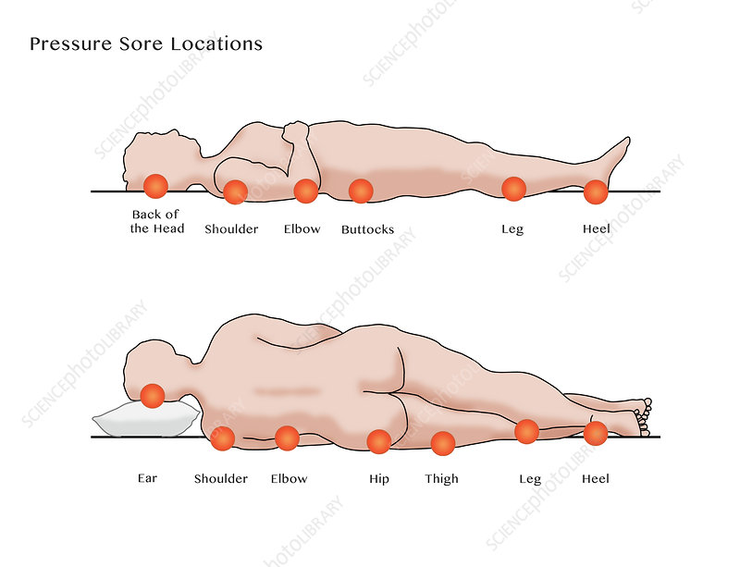

Fig 1: Bedsores pressure points in the human body

**Motivation**

Bedsores are dangerous and can have important consequences, leading to long-term hospitalization. At more severe stages, bedsores become very painful, the patient is at risk of surgery and even of death. Prevention techniques in hospitals and retirement homes today are still traditional, where the person spends a considerable amount of time regularly checking the status of their patients and their changes in body position. In the proposed system, data is gathered from many ambient pressure sensors from the individual cells of the grids to evaluate the risk areas depending on the total time of impact.

**Literature Survey**

Multiple decubitus ulcer risk assessment tools are used worldwide with the most popular being the Braden, Norton, and Waterlow scales. The Braden scale is most popular and involves a 1 to 6 ranking of a patient’s sensory perception, moisture, activity, mobility, nutrition, and friction and shear to generate a composite risk score. While quantitative, scoring can be subjective and studies have shown high variability in scoring between clinicians.

Assessment is typically performed during admission, discharge, and changes in the patient’s condition. Prevention and management of decubitus ulcers involve patient repositioning and pressure redistribution devices. Patient repositioning typically occurs every 1-2 hours to prevent tissue ischemia, though the determination of timing is somewhat arbitrary. Patients at high risk for or have already acquired an ulcer are managed with special support surfaces such as foam or gel cushions that relieve or redistribute pressure.

**Existing System**

Body pressure dispersion mattresses are useful tools for preventing pressure ulcers. Pressure-reducing mattresses redistribute a patient's weight so as to relieve pressure points. Static mattresses deliver pressure relief through the use of high-quality foam. Combinations of foam are utilized and some are castellated to further reduce shear and friction. Generally speaking, CME foam mattresses are suitable for those up to the medium risk of developing a pressure ulcer. Visco mattresses are suitable up to high risk or very high risk.

**Limitations of Existing System**

The current prediction of a pressure ulcer occurrence is using the Braden Scale approach or Waterloo Scale approach, which requires a lot of human interference and often takes up a lot of attention from the caretakers, which prevents them from serving the actual purpose. Based on studies conducted, it can be inferred that such mattresses can be effective only up to an extent and is not always effective. There is a high chance for the formation of pressure ulcers even after utilizing such mattresses.

**Proposed System**

The proposed system includes a prediction of the formation of pressure ulcers and then applies reasonable methods to prevent the same. The prediction of the pressure ulcer can be automated by using an array of sensors primarily pressure sensors and automating the entire process thereby letting caretakers focus on the primary requirement. The prevention system involves making necessary adjustments so as to reduce human interventions furthermore and therefore completely eliminate the need for human intervention.

**System Requirement Specifications (Functional & Non-Functional)**

**Functional Requirements**

The system must able to effectively predict the occurrence of a pressure ulcer and then take necessary action to prevent the same, thereby reducing human intervention. It should also be able to store the data for future analysis.

**Non-Functional Requirements**

**Proposed Methodology**

The problem can be solved by using an IoT-based approach by utilizing different sensors for prediction and motors for prevention. It involves using a low-cost approach thereby reducing costs and making it affordable for everyone.

**References**

[1]Sam Mansfield.,Eric Vin.,Katia Obraczka(2021). An IoT System for Autonomous, Continuous, Real-Time Patient Monitoring and Its Application to Pressure Injury Management. doi:[10.1109/ICDH52753.2021.00021](https://doi.org/10.1109/ICDH52753.2021.00021)

[2]Zijun Cao.,Fang Wang., Yaoguang He., Yu Zhang., Jianguo Zhang (2021). Analysis of plantar pressure in elderly diabetic patients with peripheral neuropathy. doi:[10.1109/ICPHDS53608.2021.00044](https://doi.org/10.1109/ICPHDS53608.2021.00044)

[3][Bilge Yilmaz](https://ieeexplore.ieee.org/author/37086937469)., [Ercan Atagün](https://ieeexplore.ieee.org/author/37085555621)., [Fadime ÖĞÜLMÜŞ Demırcan](https://ieeexplore.ieee.org/author/37088979735)., [İbrahim Yücedağ](https://ieeexplore.ieee.org/author/37085773171)(2021). Classification of Pressure Ulcer Images with Logistic Regression. doi:[10.1109/INISTA52262.2021.9548585](https://doi.org/10.1109/INISTA52262.2021.9548585)

[4][Therdpong Daengsi](https://ieeexplore.ieee.org/author/38234558800).,[Bundit Muttisan](https://ieeexplore.ieee.org/author/37088972879)., [Pongpisit Wuttidittachotti](https://ieeexplore.ieee.org/author/37085384865)., [Patsita ., Sirawongphatsara](https://ieeexplore.ieee.org/author/37085501633) (2021). Sustainable Development of a Prototype of Air Mattress from Re-Used Materials for Pressure Ulcer Prevention. doi:[10.1109/GECOST52368.2021.9538773](https://doi.org/10.1109/GECOST52368.2021.9538773)

[5][Malindu Ehelagastenna](https://ieeexplore.ieee.org/author/37088963383)., [Ishan Sumanasekara](https://ieeexplore.ieee.org/author/37088964057)., [Hishan Wickramasinghe](https://ieeexplore.ieee.org/author/37088964813)., [Indrajith D. Nissanka](https://ieeexplore.ieee.org/author/37086962866)., [Gayani K. Nandasiri](https://ieeexplore.ieee.org/author/37088965424)(2021).Design of an Alternating Pressure Overlay for the Treatment of Pressure Ulcers. doi:[10.1109/MERCon52712.2021.9525787](https://doi.org/10.1109/MERCon52712.2021.9525787)

[6] [Isabel Morales](https://ieeexplore.ieee.org/author/37088911288).,[Rafael González-Landaeta](https://ieeexplore.ieee.org/author/38275638900).,[Franco Simini](https://ieeexplore.ieee.org/author/38229913900)(2021)Pressure sensors used as bioimpedance plantar electrodes: a feasibility study. doi:[10.1109/MeMeA52024.2021.9478682](https://doi.org/10.1109/MeMeA52024.2021.9478682)

[7][Eman Elsharif](https://ieeexplore.ieee.org/author/37088904101)., [Nabil Drawil](https://ieeexplore.ieee.org/author/37398909200)., Salaheddine [Kanoun](https://ieeexplore.ieee.org/author/37088903982)(2021)Automatic Posture and Limb Detection for Pressure Ulcer Risk Assessment. doi: [10.1109/MI-STA52233.2021.9464360](https://doi.org/10.1109/MI-STA52233.2021.9464360)

[8][Zeinab Shayan](https://ieeexplore.ieee.org/author/37086309025)., [Mohammad Sabouri](https://ieeexplore.ieee.org/author/37086933950)., [Milad Shayan](https://ieeexplore.ieee.org/author/37088841852)., [Mohammad Hassan Asemani](https://ieeexplore.ieee.org/author/38467584900)., [Ali Bina Sarmoori](https://ieeexplore.ieee.org/author/37088841101)., [Mohammad Zare](https://ieeexplore.ieee.org/author/37088841274)(2021). Pressure control of cellular electromechanical medical mattress for bedsore prevention. doi: [10.1109/ICCIA52082.2021.9403585](https://doi.org/10.1109/ICCIA52082.2021.9403585)

[9][Eun-Bin Park](https://ieeexplore.ieee.org/author/37088643518).,[Jin-Chul Heo](https://ieeexplore.ieee.org/author/37088641214)., [Chanil Kim](https://ieeexplore.ieee.org/author/37422430600)., [Beomjoon Kim](https://ieeexplore.ieee.org/author/37088644852)., [Kwangyeol Yoon](https://ieeexplore.ieee.org/author/37088643699)., [Jong-Ha Lee](https://ieeexplore.ieee.org/author/38566958400)(2020).Development of a Patch-Type Sensor for Skin Using Laser Irradiation Based on Tissue Impedance for Diagnosis and Treatment of Pressure Ulcer. doi: [10.1109/ACCESS.2020.3048242](https://doi.org/10.1109/ACCESS.2020.3048242)

[10] Kottner, J., Cuddigan, J., Carville, K., Balzer, K., Berlowitz, D., Law, S., … Haesler, E. (2020). Pressure ulcer/injury classification today: An international perspective. Journal of Tissue Viability. doi:10.1016/j.jtv.2020.04.003

[11][Xuanchen Ji](https://ieeexplore.ieee.org/author/37088643674)., [Yasuhiro Akiyarna](https://ieeexplore.ieee.org/author/37088637223)., [Yoji Yamada](https://ieeexplore.ieee.org/author/37280504200)., [Shogo Okamoto](https://ieeexplore.ieee.org/author/37286053600)., [Hisae Hayash(2020).Development of deep clustering model to stratify occurrence risk of diabetic foot ulcers based on foot pressure patterns and clinical indices](https://ieeexplore.ieee.org/author/37088644440). doi:[10.1109/IJCB48548.2020.9304917](https://doi.org/10.1109/IJCB48548.2020.9304917)

[12][Brecht Serraes](https://onlinelibrary.wiley.com/action/doSearch?ContribAuthorRaw=Serraes%2C+Brecht),[Martin van Leen](https://onlinelibrary.wiley.com/action/doSearch?ContribAuthorRaw=van+Leen%2C+Martin),[Jos Schols](https://onlinelibrary.wiley.com/action/doSearch?ContribAuthorRaw=Schols%2C+Jos),[Ann Van Hecke](https://onlinelibrary.wiley.com/action/doSearch?ContribAuthorRaw=van+Hecke%2C+Ann),[Sofie Verhaeghe](https://onlinelibrary.wiley.com/action/doSearch?ContribAuthorRaw=Verhaeghe%2C+Sofie),[Dimitri Beeckman](https://onlinelibrary.wiley.com/action/doSearch?ContribAuthorRaw=Beeckman%2C+Dimitri)(2018). Prevention of pressure ulcers with a static air support surface: A systematic review. [doi.org/10.1111/iwj.12870](https://doi.org/10.1111/iwj.12870)

**Signature of Guide**